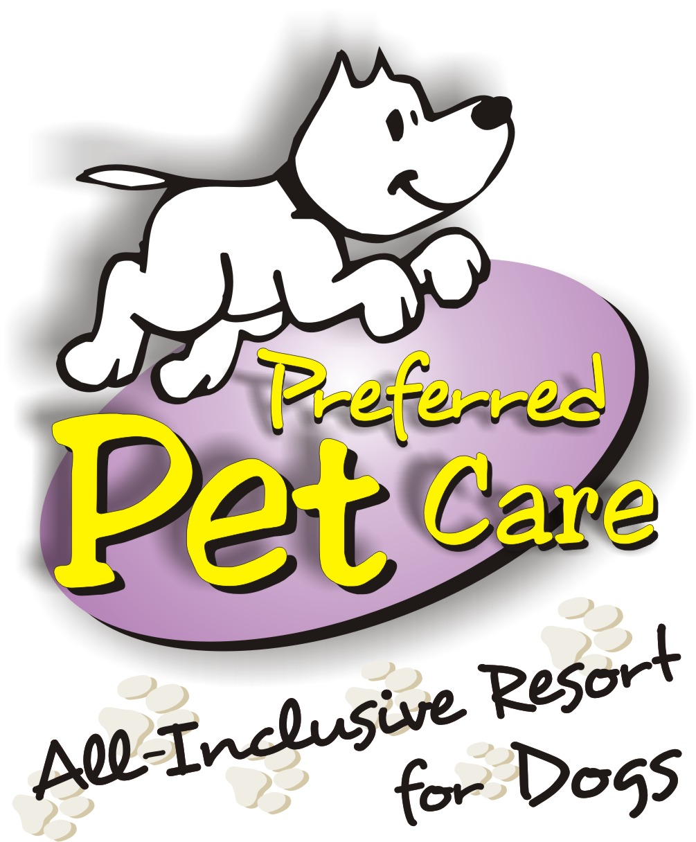

233 Rutgers Street, Maplewood, NJ 07040
www.preferredpetcare.com
Email: woof@preferredpetcare.com
Telephone: (973) 762-7007 Fax: (973) 762-5618

BOARDING INFORMATION

RATES

Overnight Rates -- $70.00 plus tax per night for one dog
$30.00 plus tax for each additional dog (Must Share A Room)

Discounts -- A discount of 10% will automatically be applied to a
stay of 10 or more nights

Check-in -- Monday-Friday 8:00 a.m. – 4:00 p.m.
Saturday-Sunday 9:00 a.m. – 12:00 p.m.
1:00 p.m. – 4:00 p.m.

Check-out -- Monday-Friday 8:00 a.m. – 12:00 p.m. *

Saturday-Sunday 9:00 a.m. – 12:00 p.m. *

* Late Pick-Up -- $30.00 for pick-up after 12:00 p.m.
$17.00 for each additional dog
(M-F: Late Pick-Up Is Until 7:00 p.m.
Sat-Sun: Late Pick-Up Is Until 6:00 p.m.)

RESERVATIONS

Please call in advance to check on availability. A 50% deposit is required in order to reserve a room. Payment in full is expected when picking up your pet. We cannot guarantee a particular type of room. Room types are subject to availability at the time of the accommodation. Please allow a minimum of 6-8 weeks in advance for holiday bookings. If someone will be dropping your dog(s) off for you, all paperwork must be filled out in advance including our client service agreement, feeding instruction sheet and medication instruction sheet. If you have made arrangements for someone to pick up your dog(s), payment must be made prior to your dog’s departure.

SUGGESTIONS

Preferred Pet Care supplies Fromm Gold Adult as our house food. However, if your dog eats another brand or has a sensitive stomach, we suggest that you bring in your own food to help prevent your dog(s) from getting an upset stomach. You are welcome to supply any diet and we will be happy to prepare it for your pet (example: cooked diced chicken, cottage cheese, lasagna, gravies, peanut butter, etc.). If your dog runs out of food during his/her stay, there will be a trip charge of $20.00 if we need to go to the store and purchase more.

Treats, dog beds, favorite blankets, toys, and anything else your pup enjoys can be set up in their room to help make your dog(s) feel more at home. These valuables will be set up and remain in your dog’s suite during the duration of his/her stay. Please make sure all beds and blankets are machine washable.

EVERYTHING BUT CUTS

Don’t forget to schedule a departure service with our bather. We recommend scheduling your dog’s bath at the time you make your reservation to ensure availability. Please inquire with our office for additional information.

HEALTH RECORDS

It is the customer’s responsibility to ensure all health records have been received by Preferred Pet Care prior to check-in. All dogs are required to have the following vaccinations before they will be admitted to Preferred Pet Care:

- Bordetella (Kennel Cough)
- Rabies
- Parvovirus/Distemper
- Canine Influenza – Must have both boosters + 1 week waiting period if it is the first time they are receiving the vaccine.

Preferred Pet Care must have a copy of all the required, updated health records prior to admittance.

CANCELLATIONS

A refund will be given only if a cancellation is made at least one week prior to the start date of the boarding date(s). All cancellations requiring a refund will be subject to a $5.00 cancellation fee. If a cancellation is made within one week of the start date of the stay, then the deposit is forfeited. You may purchase boarding insurance up to ten days prior to the start date of the boarding stay or at the time of booking. This will allow you to cancel for any reason up to 6:00 p.m. the day before check-in and we will waive the cancellation charge and issue a full refund of the boarding deposit. The cost of the insurance is non-refundable and non-transferable.

